Being away from our friends can be hard--we need a break, time to socialize and hangout with our friends. Here are some tips to help you through the next few weeks:

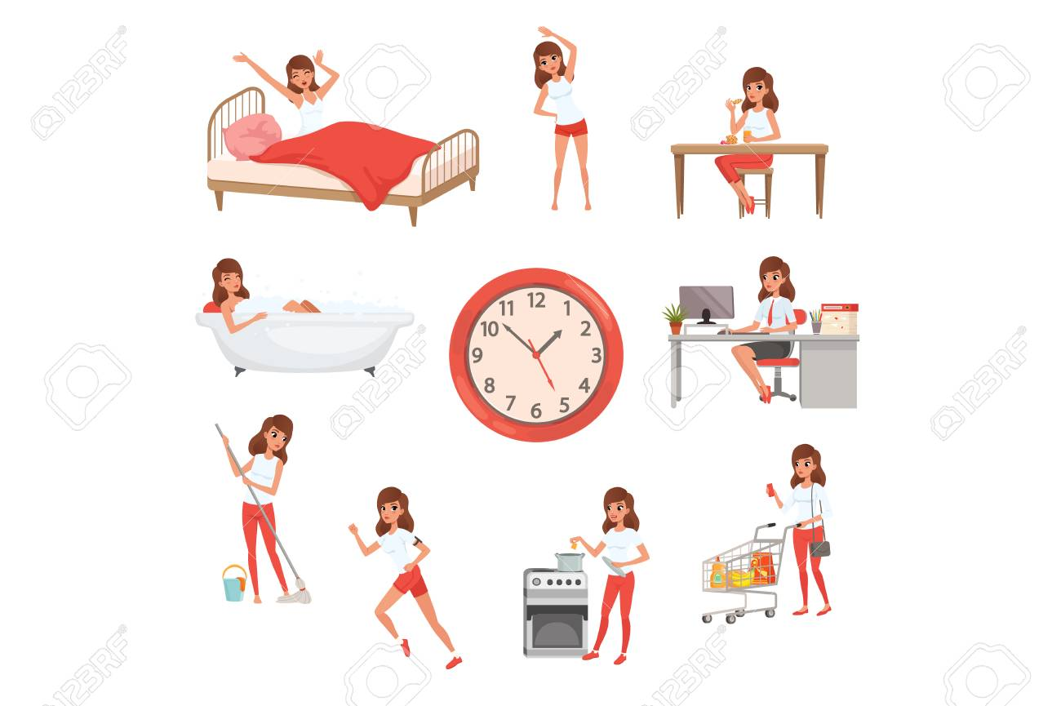
- Establish a routine! It may be hard, but maintaining a schedule (i.e. wake up at 8AM, go to bed at 10PM--that’s 10 hours of sleep!) is essential to our mental health.
Sample Routine:
8:00 Wake up and shower
9:00 Eat breakfast
9:30 Do something physical --take a walk outside, play with your pet….
10:00 on-line classes--take a 15 min break at 11 to chat on-line with friends or family
12:00 Lunch
1:00 On-line classes or reading
3:00 on-line chat with friends, catch up on social media
(tip: try to avoid info about COVID-19, being inundated with information may impact stress)
4:00 Play a game with someone in your family, build a puzzle, etc.
5:00 Help prepare dinner, do a chore or ask an adult what you can do!
6:00 Dinner-be sure to eat a healthy diet. It can be easy to “stress eat”
7:00 Call an older relative who is isolated due to social distancing
8:00 Play an online game, watch a show with someone in your family, etc.
9:00 Power down-Read (it is best to turn off electronics an hour before bed--remember we said 10 bedtime), brush your teeth, get in your jammies, make the rounds saying good-night to your family
10:00 Bed time zzzzzzzzzzzzzzzzzzz
- Stay Connected- use your positive social media apps to connect with friends and family.
Remember to avoid perseverating on COVID-19. Focus on something positive!

- Do something: color, work a puzzle, pull out a board game, play a game on-line, play with a pet, be active (did you know youtube has great exercise videos?)

- Switch things up! Make time for a movie in the morning, try something new, learn to cook/bake/paint/etc., practice a new language/instrument/etc....

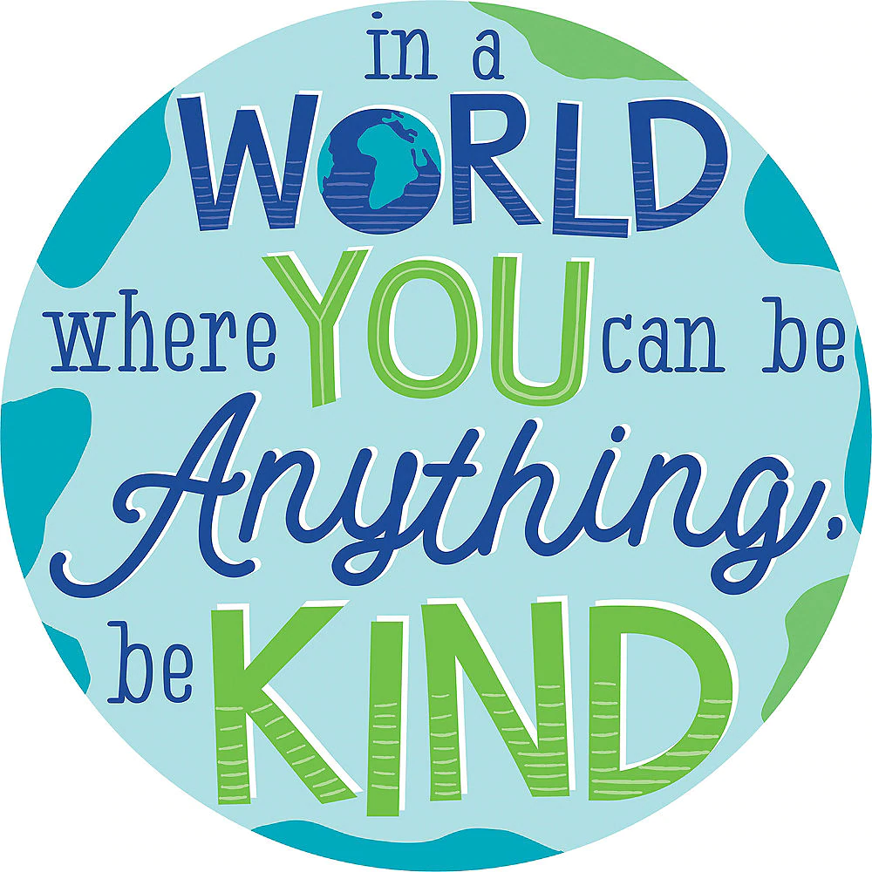
- Be kind-call an older relative or friend who is alone, listen to a friend or family member if they seem stressed, make your siblings bed, anything you can think of!

