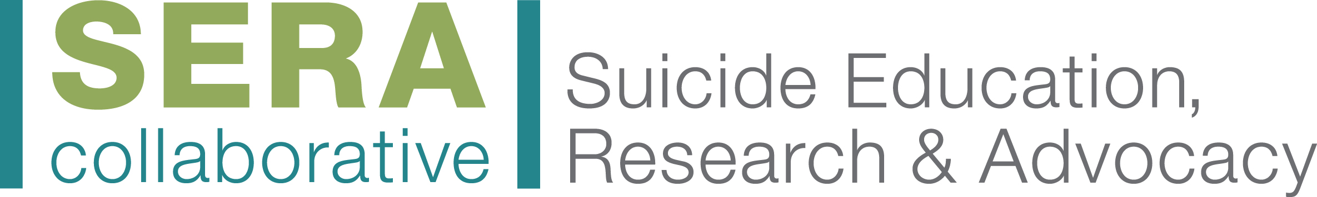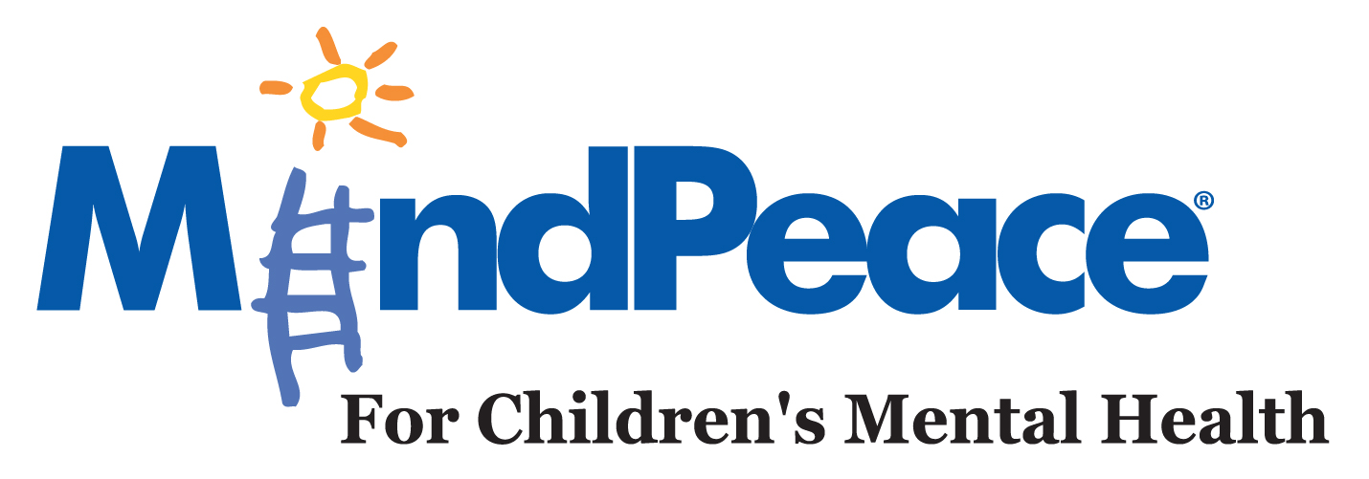
SERA recommends having teachers talk with students about where to go for help if they are struggling. Below is a script that teachers can utilize to talk with their students. Additionally, it includes information about making sure students put the local crisis number in their cell phone. This is especially important to do prior to school breaks.

Principal Email to Staff:
Teachers and Staff,
Below is a resource and script to go over with all your students in each class please. This is a crisis phone and text line for teens to reach out if they have a brain health crisis and there isn’t a caring adult that they can contact right away.
Keeping our students safe is one of the most important values we share, and your help is really appreciated. For additional brain health supports for our students, please remember that you can always speak with me, and talk with our wonderful counselors and our school-based mental health partner.
Thank you for your help.

TEACHER SCRIPT:
I want to make sure you have resources you can always contact in case you are having a brain health crisis and there isn't a caring adult you can talk with right away.
Please take out your cell phones so you can put these resources into your phone contact list now.
CRISIS HOTLINE: 1-800-273-TALK (8255) or say "Suicide" to Siri on Apple Products
Hamilton County Text Line: 839863 and text 4hope
National Text Crisis Line: 741-741 and text 4hope

Please also Write on Board
If you feel that you or a friend is in a crisis situation and/or fearful of hurting yourself or others and there isn't a caring adult you can reach right away, please contact 1-800-273-TALK (8255) or text 4hope to 741-741. Take this time to put these as contacts in your phone. These crisis lines are operated 24/7, so please call anytime you have questions or concerns, day or night.

