Self-Care Guide
January 2018

table of contents
I. What is Self-Care & What are the Benefits?................................................................................................................3
II. Burnout, Compassion Fatigue & Secondary Traumatic Stress……………………………………………....………….4
Tips for Decreasing the Effects of Trauma Exposure and Stress……………………..…………….…….…..5
III. Who Should Practice Self-Care?...................................................................................................................................5
Self-Care for Therapists……………………………………………………………………………………………………………....5
Self-Care for Teachers and School Staff………………………………………………………………………………......…….6
Self-Care for Students………………………………………………………………………………………………………………….6
Self-Care for Parents and Families……………………………………………….…………………………………………….…6
IV. Facets of Self-Care………………………………………………………………………………………………………….………………..7
Physical………………………………………………………………………….……………………………………….…………..........7
Psychological……………………………………………………………………….……….…………………………………………....7
Spiritual………………………………………………………………………………………………………………………………..…..8
V. Methods/Tools of Self-Care………………………………………………………………………………………………………..........9
Books……………………………………………………………………………………………………………………………………..….9
Interactive Tools……………………………………………………………………………………………………………………......9
Online………………………………………………………………………………………………………………..…..……..….9
Magazines………………………………………………………………………………………………………………………..9
Apps…………………………………………………………………………………………………………………………………10
Videos………………………………………………………………………………………………………………………………10
VI. Developing a Self-Care Plan……………………………………………………………………………………………………...…...11
APPENDIX A: PUTTING SELF-CARE INTO PRACTICE………………………………………………………….………..………12
I. Office Stretches………………………………………………………………………………………………..………………...…..12
II. List of Self-Care Activities……………………………………………………………………………..………………………..12
III. Brain Break Ideas……………………………………………………………………..………………………………………….14
APPENDIX B: TIPS FOR GOOD SLEEP……………………………………………………………….………………………………….15
APPENDIX C: SAMPLE SELF-CARE PLAN………………………………………………………………………………………….…..17
REFERENCES……………………………………………………………………………………………………………………………………….19

I. What Is Self-Care & What Are the Benefits?

Self-care refers to the activities and routines practiced to benefit one’s psychological, physical, and spiritual well-being. Self-care activities should be practiced on a regular basis to promote mental well-being. Learning something new, focusing on breathing, physical exercise and expressing creativity are all examples of self-care activities. Self-care can be as simple as waking up 10 minutes earlier than you normally would so that you have time to enjoy your morning coffee in peace. Self-care can also be as luxurious as treating yourself to a professional massage.
It is important to recognize the difference between self-care and self-indulgence. According to an article written by licensed psychologist, Christine Meinecke (2010), “Self-indulgence is characterized by avoidance of the effortful and substitution of quick and easy antidotes.” In other words, self-indulgence typically involves using the term “self-care” as a way to justify behaviors that only temporarily relieve stress, such as alcohol consumption, turning to food for comfort, and binge-watching television. These behaviors may relieve stress quickly and temporarily but could have detrimental long term effects on one’s health. Self-care is focused on managing and preventing stress and exhaustion in ways that are beneficial to our overall well-being.
Research has shown that there are many benefits of a comprehensive self-care plan. Self-care activities have been proven to:
- Reduce stress
- Increase productivity
- Improve health
- Help one achieve work-life balance
- Prevent burnout and compassion fatigue

II. Burnout, Compassion Fatigue & Secondary Traumatic Stress

Burnout is "a state of mental and/or physical exhaustion caused by excessive and prolonged stress," (Center for Mental Health in Schools at UCLA, 2015). Burnout occurs in three stages: Stress Arousal, Energy Conservation, and Exhaustion. The Stress Arousal stage includes both physiological and psychological responses, which could include irritability, bruxism (grinding teeth at night), headaches, and forgetfulness. The second stage of burnout, Energy Conservation, might include symptoms such as procrastination, excessive time off work, social withdrawal, and increased substance abuse. The final stage of burnout, Exhaustion, could involve sadness, suicidal ideations and chronic headaches or gastrointestinal problems. These stages typically occur sequentially, but intervention to stop the process can begin at any stage.
According to the National Child Traumatic Stress Network (2011), Secondary Traumatic Stress (STS) is the emotional burden that results when an individual hears about the first hand trauma experiences of another. Symptoms of STS can be similar to those of post-traumatic stress disorder including hypervigilance, guilt, fear, and re-experiencing personal trauma. Research has shown that experiencing STS is oftentimes a predictive factor that a therapist or other helping professional will eventually leave their career and enter a different line of work (Fact Sheet).
The Compassion Fatigue Awareness Project (2017) refers to Compassion Fatigue as an STS disorder caused from focusing on others without practicing self-care. Symptoms of compassion fatigue include, but are not limited to:
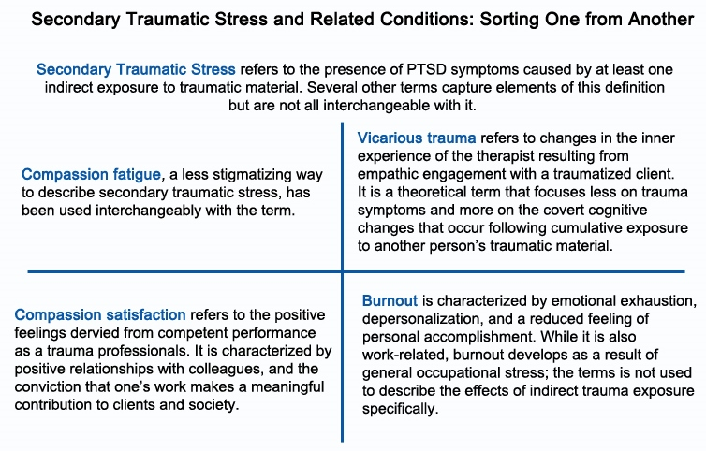
- Apathy
- Isolation
- Compulsive behavior
- Mental and physical fatigue
- Difficulty concentrating

(National Child Traumatic Stress Network, 2011)

Tips for decreaseating the effects of trauma exposure and stress

- Be mindful of the physical environment around your workspace and or/agency and how it could invite more joy, fun and creativity.
- Create “go-to” box of comfort care items that help you engage in playfulness, relaxation or are re-energizing.
- Establish a coloring area for staff.
- Include creativity into staff meetings by beginning with a poem, song or story that relates to the organization’s mission or values. Invite staff to take turns being responsible for this activity.
- Support colleagues through notes of gratitude, affirmation or inspiring quotes. This could be done through using stickers, magazine collages or other expressive ideas.
For more details visit: https://www.starr.org/training/tlc/blog/self-care-creativity-trauma-informed-workplace

III. Who Should Practice Self-Care?

Ideally, self-care should be practiced by everyone. However, those who have a career as a caregiver or those who work in a field where employee burnout is common should view self-care as a high priority. A self-care plan can be used for both prevention and treatment of stress. Those who are already experiencing workplace stress should practice self-care, but those who may not yet be experiencing stress should practice it also.

Self-Care for Therapists
According to an article from the American Psychological Association (2005), therapists, due to their line of work, are at a risk for psychological problems. Research shows that 50% of professionals who work with trauma patients report feeling distressed. Therapists face the challenge of managing multiple nonreciprocal relationships, meaning the therapist is listening to the problems and experiences of multiple clients and focusing solely on his or her clients during working hours.

Self-Care for Teachers and School Staff
Teachers experience a lot of job pressure that can put them at risk for job burnout. Standardized testing, lack of classroom resources, and managing unmotivated or disrespectful students can all be factors leading to distress in teachers (BLS, 2015).
It is ideal for teachers to practice self-care throughout the school day. Time between class periods can be utilized for a quick mindful meditation before the next class of students arrives. This time can also be used for some light stretching. Practicing self-care with students can give both the teacher and students a designated time to practice self-care. This will also demonstrate to students the importance of practicing self-care. Teachers can practice self-care with their students by:
Check out this resource on Mindful Teachers for tips on practicing self-care!
http://www.mindfulteachers.org/p/self-care-resources.html

Self-Care for Students
Students should start practicing self-care at any early age. Self-care can be especially beneficial to students who may be exposed to traumatic environments. Self-care is also beneficial for students exposed to high performing environments. In order to ensure students are learning about self-care, teachers can practice self-care with their students in various ways:
- Utilize kinesthetic brain breaks during class periods. This involves getting students out of their seats to participate in a 1-3 minute activity to think and move the body (See Appendix A for examples)
- Taking breaks to energize with a healthy snack during class, if allowed by the teacher
- Celebrate small moments—have a small “end of the semester” celebration
- Take a walk outside on a nice day

Self-Care for Parents and Families
Parents and families should also practice self-care. Parents today can be very overwhelmed attempting to keep up with all of the demands and stresses of family life. Parents often focus on the health of their child, rather than worrying about their own health. Some ways parents can practice self-care include:
- Planning regular date nights to spend time together
- Making sure you take time out of your day to eat, rather than skipping meals
- Taking a 30-minute walk outside before the kids wake up
- Keeping in touch, and making time for friends
- Taking time to read or do something you enjoy by yourself
- Enjoying family dinners without the distractions of electronics or television

IV. Facets of Self-Care

Approaching self-care as a multi-faceted concept can be helpful in the process of creating a self-care plan and helping promote a balanced approach to stress management. Practicing self-care in one of these categories may positively influence another aspect as well. For example, “nearly two-thirds of adult yoga users reported that as a result of practicing yoga they were motivated to exercise more regularly, and 4 in 10 reported they were motivated to eat healthier,” (NCCIH, 2016).
Physical
According to Utah State University Counseling and Psychological Services, “Physical self-care involves activities that improve physical health, including diet and exercise, being active, consuming foods with high nutritional value, and getting plenty of sleep” (2010). Evidence shows that participating in regular physical activity can improve mental well-being (Taylor, Sallis, & Needle, 1985). In addition, research has shown that exercise can alleviate long-term depression (APA, 2011).
Examples of physical self-care include:
- Be in nature. Take a walk around the building during the work day to give yourself a quick mood boost.
- Inhale, diffuse, or apply essential oils to your skin, such as lavender or rose to relax during times of stress.
- Stretch at your desk (Appendix A).
- Developing a regular sleep schedule.
According to the CDC, sleeping less than 7 hours per night is linked to increased risk of poor mental health (2016). See Appendix B for tips on sleep.
- Eat nutritious foods such as fruits, vegetables and lean meats, and limiting refined carbohydrates and added sugar.
- Drink water! – The current Institute of Medicine recommendation is 13 cups for men and 9 cups for women per day (NASEM, 2015).
- Physically remove oneself from areas of crisis or trauma.
- Exercise or dance to get out extra energy and relax. This helps to release endorphins (chemical in your brain) that make a person feel good.
- Participate in expressive art therapy including poetry, writing or coloring.

Psychological
Psychological self-care involves taking care of your emotions and mental well-being. Setting healthy boundaries, learning when to say no to extra commitments, and overcoming perfectionism all fall under the category of psychological self-care.
- See a therapist regularly or during times of high stress (Check with your employer to see if these visits are covered under your EAP).
- Participate in support groups.
- Keep a journal to clarify thoughts.
Evidence shows that writing about stressful events helps come to terms with them, reducing the impact they have on your life (Psych Central, 2016).
- Take a break from television, social media and the internet to avoid exposure to negative information.
- Seek out peer support. Talk with others who have shared experiences or develop/engage in compassionate friendships with others.
- Be an active member of your community.
- Empower yourself through learning and psychoeducation.
- Look at pictures of loved ones.
- Advocate for others. Find ways to make changes for the betterment of society.
- Express emotional healing practices of crying, laughing or story telling.

Spiritual
Spiritual self-care involves caring for your soul. Spiritual wellness involves seeking a purpose and meaning in human life. Practicing spiritual self-care can help you find peace between your inner feelings and emotions and the stressors of your life. Ways to practice spiritual self-care include:
- Meditation
- Yoga
- Prayer/Attending a church service
- Expressing gratitude
Additional healing practices are available at: https://alamedacountytraumainformedcare.org/trauma-survivors-and-family/self-care-tips/
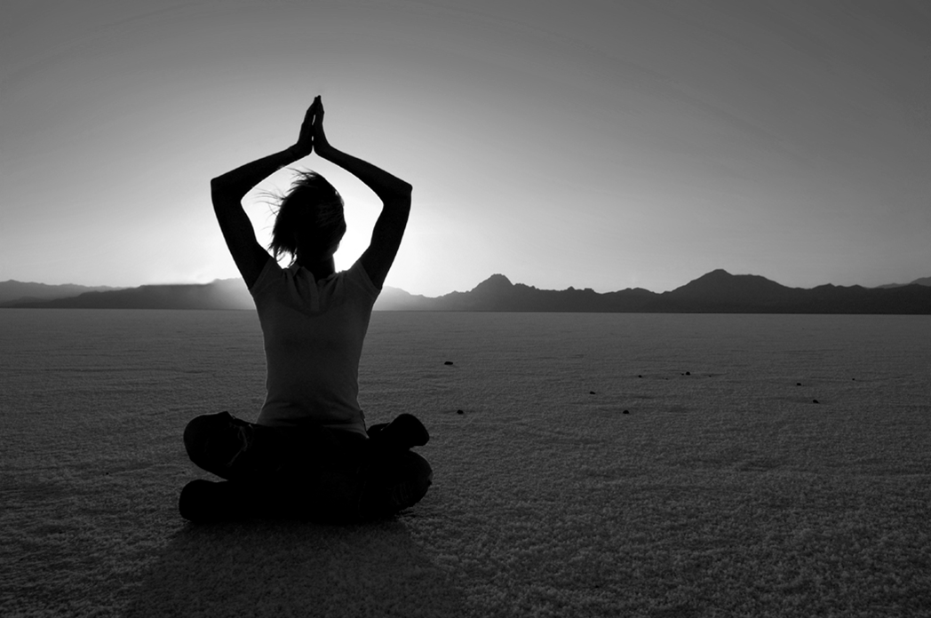

V. Methods/Tools of Self-Care

Books
- Self-Compassion by Kristin Neff, PhD (2015) “This book offers expert advice on how to limit self-criticism and offset its negative effects, enabling you to achieve your highest potential and a more fulfilled life” (Self Compassion, 2017).

- Trauma Stewardship: An Everyday Guide to Caring for Self While Caring for Others by Laura van Dernoot Lipsky (2007) “This book is a navigational tool for remembering that we have options at every step of our lives. We choose our own path. We can make a difference without suffering; we can do meaningful work in a way that works for us and for those we serve. We can enjoy the world and set it straight. We can leave a legacy that embodies our deepest wisdom and greatest gifts instead of one that is burdened with our struggles and despair” (Inside the Book, 2017).

- The Gifts of Imperfection by Brene Brown (2010) “In this best-selling book, a researcher of Shame and Vulnerability talks about the journey to 'Whole heart' living via her 10 guide posts to help readers realize their real strength of character through the courage to accept their imperfection” (The Gifts of Imperfection, 2017).

Interactive Tools
ONLINE:
- Life Journal: This is an online journaling platform that provides a word processing tool for private journaling, journal prompts, and a way to keep journal entries organized by topic and date. (www.LifeJournal.com)

- Mindcheck: Visit this site for interactive tools to help with stress, relaxation techniques, healthy thinking and more. (http://mindcheck.ca/stress/stress-self-care-resources)

MAGAZINES:
- Spirituality & Health: This is a magazine which covers a range of topics including health and spirituality, meditation, wellness, nutrition, creativity, holistic medicine and more. Subscribe at www.spiritualityhealth.com for $24.95/year.

- SelfCare Magazine: This is a digital resource of podcasts, newsletters, and self-care tips for professionals who want to be happier and healthier at work and home. (www.myselfcaremagazine.com)

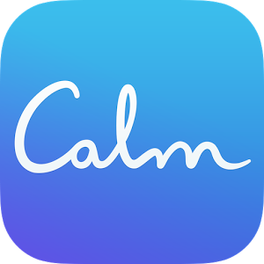
APPS:
- Calm: This is an application for a mobile device that helps the user practice mindful meditation and also provides an option for “sleep stories” to help the user fall asleep.

- Sleep Cycle: This is an application which serves as an alarm clock that tracks the users sleep cycles and wakes the user up during light sleep. Waking up during light sleep is the natural waking point, allowing the user to feel more rested than waking up by an alarm during deep or REM sleep.
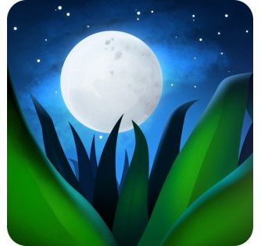
- Relax Melodies: This is an application for a mobile device that helps the user fall asleep. The user can combine melodies to listen to. The application focuses on integrating mindfulness into the user’s sleep routine.
- YogaGlo: This is an application for a mobile device which has yoga and meditation classes at all levels for $18/month.

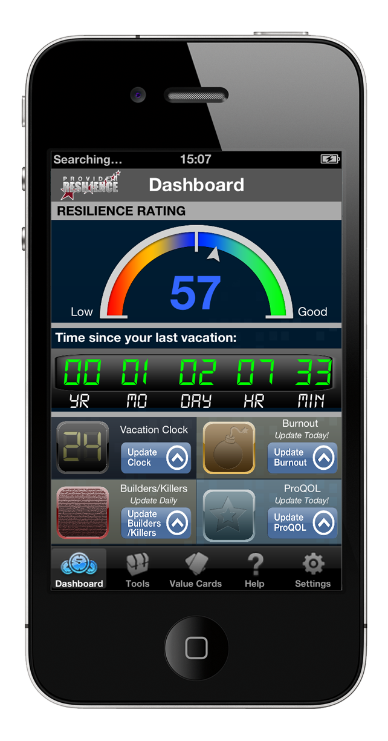
- Provider Resilience: This is an application for a mobile device
for caregivers prone to burnout, compassion fatigue and secondary traumatic stress. The app provides tools to help the provider remain emotionally healthy and productive via self-assessment and overall resilience ratings. Available for android and iOS devices.

VIDEOS:
- “Just Breathe” YouTube: This YouTube video is 2 minutes of simple, mindful breathing (https://www.youtube.com/watch?v=Eqyj6Rp2Q1w)

- Gaia: With Gaia, you can stream yoga videos online to practice yoga anywhere! https://www.gaia.com/yoga/practices?utm_source=google+paid&utm_term=+yoga%20+on%20+tv&utm_campaign=1-usa-yoga-general-broad&utm_content=yoga-tv-channel-broad&utm_medium=cpc&ch=my

- “Beyond the Cliff” Ted Talk by Laura van Dernoot Lipsky https://www.youtube.com/watch?v=uOzDGrcvmus

VI. Developing a Self-Care Plan

Self-care is dynamic and different for everyone. For someone who is developing their own, personalized self-care plan, it is important to take some time for self-reflection. Here are some steps to get started on developing a self-care plan.
- Get to know yourself. Below is a list of questions, adapted from Safe Place’s Staff Self-Care Plan Worksheet (Reiser and Butler, n.d.) that may be helpful to guide your self-reflection and to establish a starting point for the development of your self-care plan.

- Name some situations that typically cause you to feel stressed or overwhelmed
- How does your appearance or behavior change when you feel that you are losing control? (Ex. Red face, swearing, unable to listen, blaming others for problems, walking away from problems)
- What are your actions when you feel that you have lost control? (Ex. Crying, yelling, shutting down, becoming aggressive)
- What helps you when you feel upset, overwhelmed, or stressed? (Breathing deeply, talking to friends, napping, etc.)

- Make a list of self-care activities that you enjoy doing and that are beneficial to your well-being. You can come up with your own from past experience, browse the web, or check out a list of self-care ideas in Appendix A of this report.

- Create a hard copy of your self-care plan. The plan can be hand written or electronic. The importance of this step is that your plan is accessible and easy to reference and modify. See Appendix C for a sample self-care plan.
It is important to utilize your self-care plan once you have created it. Here are some suggestions to help make self-care a habit:
- Schedule self-care time into your planner/agenda
- Write your self-care plan on an index card and carry it with you in your purse or wallet
- Store your self-care plan in the “notes” section of your smart phone
- Explore new ways to practice self-care to stay inspired

Appendix A: Putting Self-Care into Practice

I. Office Desk Stretches

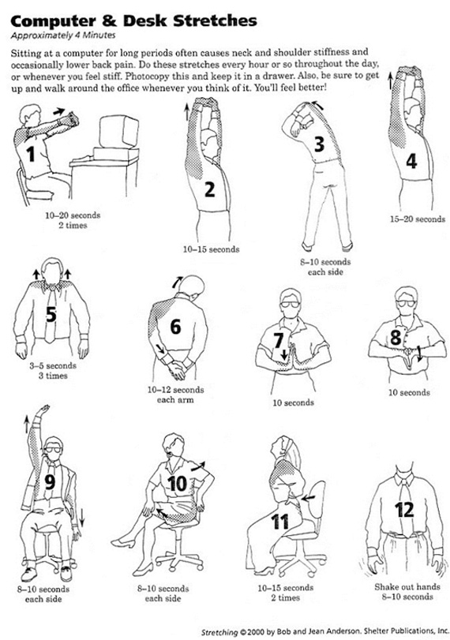

II. List of Self-Care Activities (Adapted from Safe Place Worksheet)
Physical
- Do physical activities that are fun
- Eat regular healthy meals
- Exercise
- Get enough sleep
- Get a massage
- Get routine medical care for prevention
- Stretch
- Take a break from technology
- Wear clothes that you are comfortable in
Psychological
- Do something you’re a beginner at
- Make time for self-reflection
- Read literature that is not related to your work
- Say no to extra responsibilities sometimes
- Spend time outdoors
- See a psychotherapist or counselor
Workplace/Professional
- Arrange your workspace so it is comfortable
- Ask for help when needed
- Balance your workload so that no one day is too much
- Start a peer support group
- Use paid time off
- Take a real break every few hours
- Don’t eat at your desk
Emotional
- Allow yourself to cry
- Feel proud of yourself
- Express outrage in constructive ways
- Play with children
- Spend time with pets
- Reread favorite books
- Stay in contact with important people in your life

Spiritual
- Be open to mystery and the unknown
- Attend a church or religious service
- Pray
- Sing
- Listen to inspiring music
- Spend time in nature
- Celebrate rituals that are meaningful to you
- Memorialize loved ones who have passed on
- Meditate

III. Brain Break Ideas:
Brain breaks are quick and effective in changing your physical or mental state. They are useful for students to help activate and stimulate their brains. Research shows brain breaks can help improve students’ concentration and relieve stress.
Find more ideas on how to incorporate brain breaks here:
http://www.pgsd.org/cms/lib07/PA01916597/Centricity/Domain/43/Brain%20Breaks.pdf

Appendix B: Tips for Good Sleep

1. Go to bed at a set time each night and get up at the same time each morning—even on weekends.
- Sleeping in on weekends can make it harder to wake up Monday morning
- Get homework/work done early so you are not up late at night finishing it
2. Exercise during the day.
- Strive for a minimum amount of exercise 30 minutes a day
- Exercising immediately before bed can interfere with sleep (exercise 5-6 hours prior)
3. Avoid caffeine, nicotine, and alcohol, especially before bed.
- Avoid coffee, chocolate, soft drinks, non-herbal teas, diet drugs, some pain relievers
- Smokers tend to wake up too early due to nicotine withdrawal
- Alcohol robs people of deep sleep and REM
4. Try relaxing activities before bed.
- Warm bath, reading, music, drawing, writing
5. Expose yourself to bright light when you wake up.
- Sunlight helps the body’s internal biological clock reset each day
- Experts recommend exposure to an hour of morning sunlight
6. Don’t lie in bed awake.
- Do something relaxing if you cannot fall asleep, until you are tired
- The anxiety of not being able to fall asleep can contribute to insomnia
7. Create a sleep environment.
- Create a comfortable bed with enough pillows and blankets
- By only sleeping in your bed you can create an association between bed and sleep
8. Keep electronics out of bed.
- Limit usage an hour before bed since devices stimulate the mind
- Keep electronics tucked away and out of reach
- Use an alarm clock instead of your phone
9. See a doctor if your sleeping problem continues.
Information gathered from: National Institutes of Health (www.nih.gov)
Adolescent Sleep Tips:

Elementary Sleep Tips:
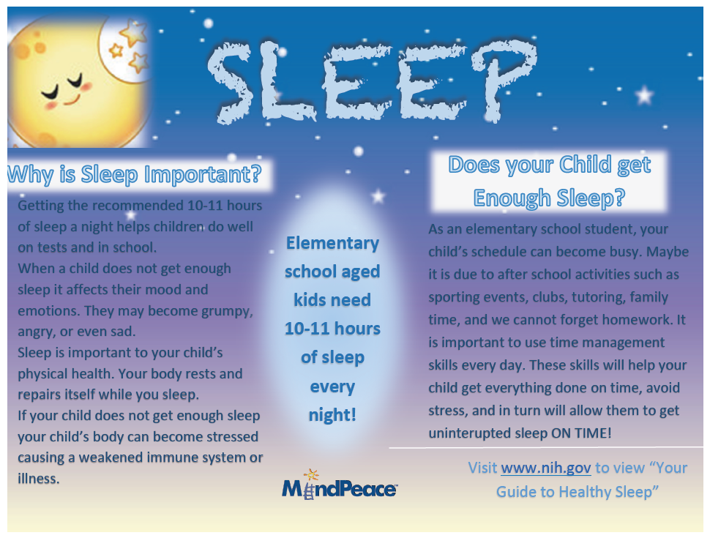

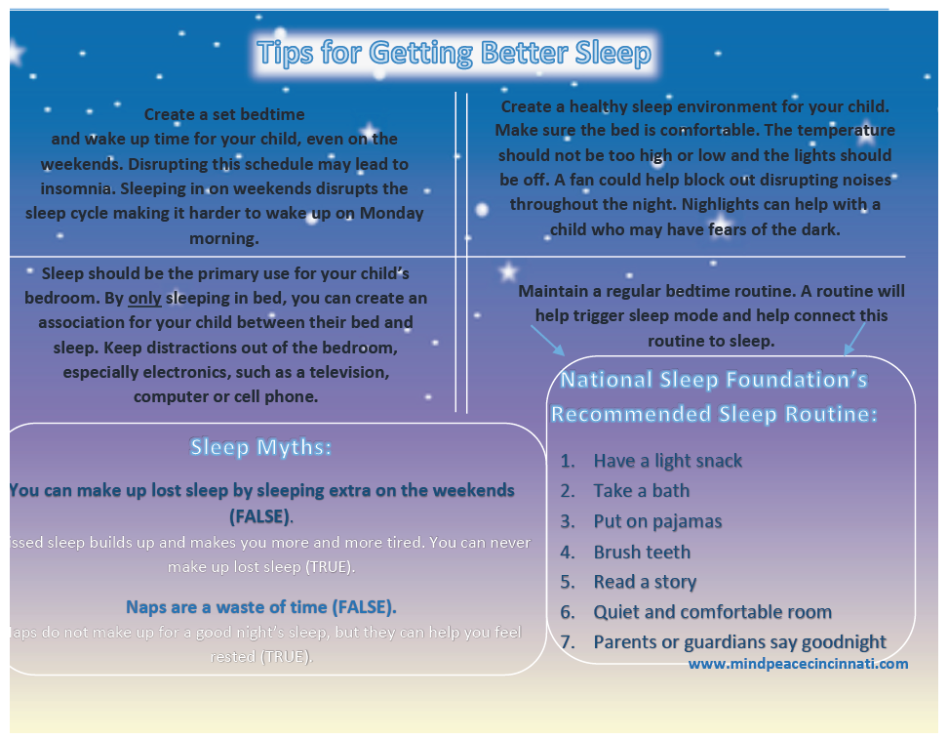

Appendix C: Sample Self-Care Plan
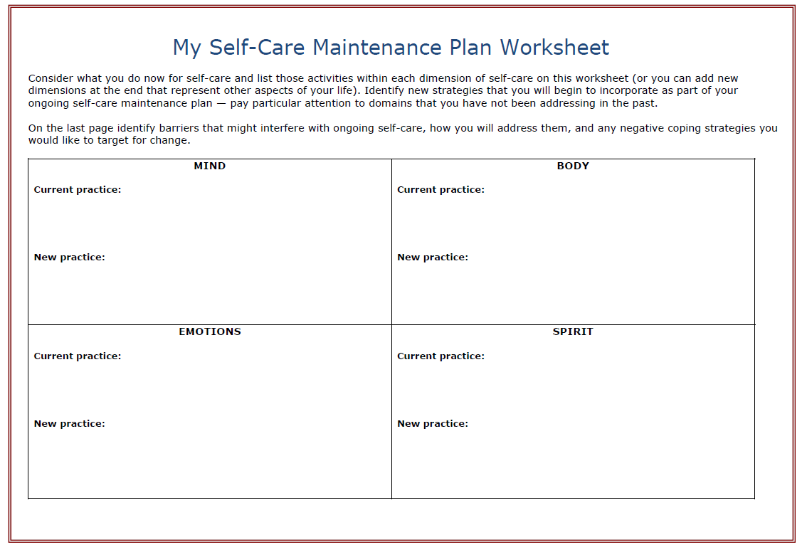

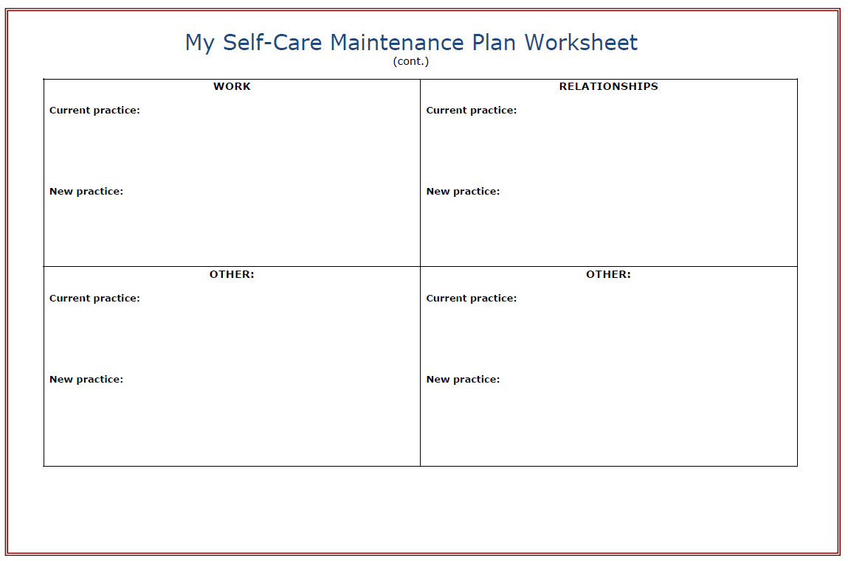

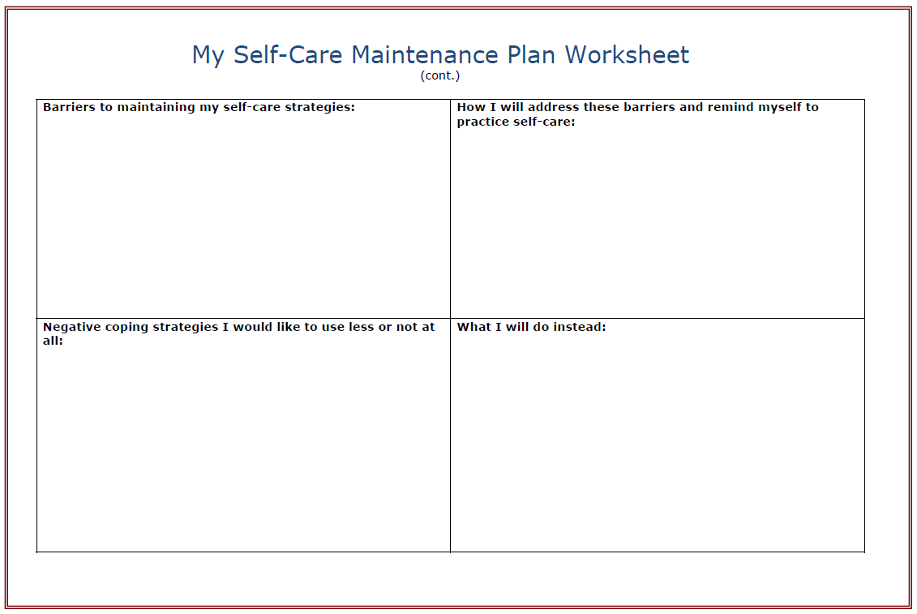

References

Alameda County Behavioral Health Care services. (2013). Self Care Tips | Alameda County Trauma Informed Care. Retrieved from https://alamedacountytraumainformedcare.org/trauma-survivors-and-family/self-care-tips/

Anderson, B., & Anderson, J. (2000). Computer & Desk Stretches [Diagram].

APA Practice Organization. (2005, January 18). Risk Factors and Self-care for Practitioners
Working With Trauma Clients. Retrieved from http://www.apapracticecentral.org/ce/self-care/trauma-clients.aspx?_ga=2.109007298.1112390819.1502117864-160168522.1467818205

Bureau of Labor Statistics. (2017). Occupational Outlook Handbook: High School Teachers.
Retrieved from https://www.bls.gov/ooh/education-training-and-library/high-school-teachers.htm#tab-3.

Centers for Disease Control and Prevention. (2016, February 23). Getting Enough Sleep?
Retrieved from https://www.cdc.gov/features/getting-enough-sleep/

Center for Mental Health in Schools at UCLA. (2015). Understanding and Minimizing Staff
Burnout [PDF file]. Retrieved from
http://smhp.psych.ucla.edu/pdfdocs/burnout/burn1.pdf.

Compassion Fatigue Awareness Project. (2017). What is Compassion Fatigue? Retrieved
from http://www.compassionfatigue.org/pages/compassionfatigue.html.

Danneman, I. (2016, January 12). 5 Ways to Incorporate Heavy Work into a Special Education
Classroom. Retrieved from http://www.friendshipcircle.org/blog/2016/01/12/incorporate-heavy-work-into-a-special-education-classroom/

Gaia. (n.d.). All Yoga. Retrieved from
https://www.gaia.com/yoga/practices?utm_source=google%2Bpaid&utm_term=%
2Byoga %2Bon %2Btv&utm_campaign=1-usa-yoga-general-broad&utm_content=yoga-tv-channel-broad&utm_medium=cpc&ch=my

Google Books. (n.d.). The Gifts of Imperfection. Retrieved from
https://books.google.com/books/about/The_Gifts_of_Imperfection.html?id=KCghogEA CAAJ&hl=en

Inspired By Lucile. (2016, December 31). Self Care Saturday Challenge Plan Your Self Care.
Retrieved from http://inspiredbylucile.com/2016/12/31/self-care-saturday-challenge-plan-your-self-care/

Life Journal (n.d.). Retrieved from https://www.lifejournal.com/

Lipsky, L. V. N. (2009). Trauma Stewardship: An Everyday
Guide to Caring for Self While Caring for Others. San Francisco, CA: Berrett-Koehler

Meinecke, C. (2010, June 5). Self-Care in a Toxic World [Web log post]. Retrieved from
https://www.psychologytoday.com/blog/everybody-marries-the-wrong-
person/201006/self-care-in-toxic-world

Mindcheck.ca. (n.d.). Stress Self-Care Resources. Retrieved from
http://mindcheck.ca/stress/stress-self-care-resources

Mindful Teachers. (n.d.). Self-care resources. Retrieved from http://www.mindfulteachers.org/p/self-care-resources.htm

National Center for Complementary and Integrative Health. (2016, June 22). What
Complementary and Integrative Approaches Do Americans Use? Retrieved from
https://nccih.nih.gov/research/statistics/NHIS/2012/key-findings

National Center on Safe Supportive Learning Environments. (2017, August 01). Safe Place:
Trauma-Sensitive Practice for Health Centers Serving Students. Retrieved from
https://safesupportivelearning.ed.gov/Trauma-Sensitive-Campus-Health-Centers

National Child Traumatic Stress Network, Secondary Traumatic Stress Committee. (2011).
Secondary traumatic stress: A fact sheet for child-serving professionals [PDF file].
Retrieved from
http://nctsn.org/sites/default/files/assets/pdfs/secondary_traumatic_tress.pdf.

National Institutes of Health. (n.d.). Retrieved from https://www.nih.gov/

Purcell, M., LCSW, CEAP. (2016, July 17). The Health Benefits of Journaling. Retrieved from
https://psychcentral.com/lib/the-health-benefits-of-journaling/

Reiser, LCSW, S., & Butler, PhD, L. D. (n.d.). My Self-Care Maintenance Plan Worksheet
[worksheet].
Self-Compassion. (n.d.). Retrieved from http://self-compassion.org/

Taylor, C. B., Sallis, J. F., & Needle, R. (1985). The relation of physical activity and exercise to
mental health. Public Health Reports, 100(2), 195–202.

The National Academies of Sciences Engineering Medicine. (2015). Dietary Reference Intakes:
Water, Potassium, Sodium, Chloride, and Sulfate : Health and Medicine Division. Retrieved from http://www.nationalacademies.org/hmd/Reports/2004/Dietary-Reference-Intakes-Water-Potassium-Sodium-Chloride-and-Sulfate.aspx

The Trauma Stewardship Institute. (2016). Inside the Book. Retrieved from
http://traumastewardship.com/inside-the-book/

The Value Factory. (2015, June 30). 2 minute mindfulness - simple, mindful breathing [Video
file]. Retrieved from https://www.youtube.com/watch?v=Eqyj6Rp2Q1w

Utah State University. (2010). Utah State University - Counseling and Psychological Services.
Retrieved from https://www.usu.edu/counseling/resources/self_help.cfm
Vicarious Trauma. (n.d.). Retrieved from https://www.counseling.org/docs/trauma-disaster/fact-sheet-9---vicarious-trauma.pdf

Weir, K. (2011, December). The exercise effect. Retrieved from
http://www.apa.org/monitor/2011/12/exercise.aspx

