Calming Spaces
Inside the School

Table of Contents
Calming Space 2
Sensory Item Examples 3
Furnishings/Atmosphere Examples 4
Photos 5
Resources: 8

Calming Space

Purpose: The Calming Room is a supportive therapeutic environment which assists students in their self-calming efforts by offering them an environment of relaxation. It is a designated place designed to calm the senses where the student can experience calming visual, auditory, and tactile stimuli. They are designed and furnished to provide an area of low stimulus and provide mindfulness and destressing activities. It can offer students working with each other to relieve stress or also offers an absence of peer interpersonal interactions for the purpose of tension reduction.
Calming rooms can be a place for student’s to be sent after acting out in the classroom. It is used as a tool to teach students calming techniques in order to decrease agitation, aggressiveness, irritation, sadness, etc. This gives them the chance to calm themselves before trying to process the cause of their actions/misbehavior. They can develop skills here that they can use outside of school to benefit their wellbeing; self-awareness, resiliency, and self-care.
Calming rooms also provide a space for students to go to prevent teacher “burn out”. If a student is acting out, over stressed, upset, etc. the comfort room is available for them to rid the negativity and return fresh to their classroom in a better state to learn. In turn, the room provides a safe place for the teacher to send the student who may be a distraction to the other students in their classroom.
This sensory supportive environment will provide tools to help students understand their behavior and refocus. These tools can include inexpensive and reusable items to help with cost and low maintenance for upkeep. Sanitation products should be available to keep the area and items germ free.

Sensory Item Examples
**can apply to high school**
- Stress balls **
- Books **
- Coloring **
- Puzzles **
- Leggos **
- Writing journals **
- Calming worksheets **
- Play Doh
- Stuffed animals
- Bubble wrap **
- Cards **
- Beads and string **
- Bubbles
- Grooming kits **
- Different textured balls **
- Exercise band **
- Slinky **
- Finger painting **
- Etch-a-sketch
- Pipe cleaners
- Massage tools **
- Self-help books **
- Books written by recovered individuals **
- Craft basket **
- Dry erase boards **
- CD Player **
- Mindfulness CD **
- Noise blocking headphones **

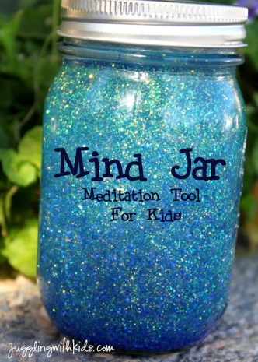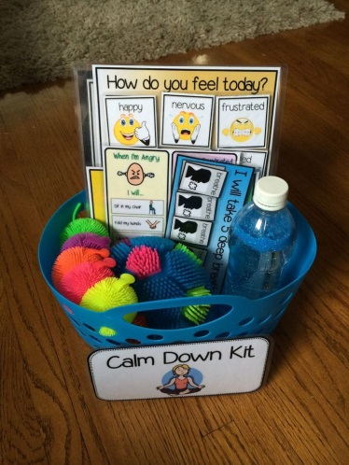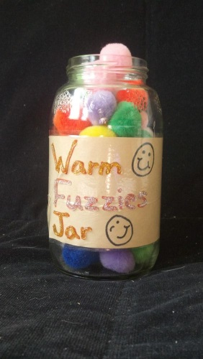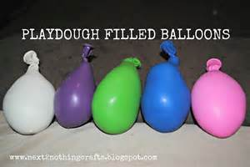

Furnishings/Atmosphere Examples

An ideal comfort room’s atmosphere provides an utmost sense of relief. The room itself is decorated to relieve stress. Furnishings, setting, etc. can include:
- Fabric covering to dim the lights
- Curtains
- Bean bag chairs
- Carpet space
- Carpet squares
- Yoga mats
- Rocking chair
- Recliner
- Canopy’s
- Calming posters (meditation, breathing techniques, positivity, etc.)
- Lava lamps
- Plants
- Glow stars
- Murals painted by youth or staff
- Youth’s art
- Scent box (peppermint or lavender)
- Calming music
- Organization
- Sanitation supplies
- Desk privacy dividers

Photos

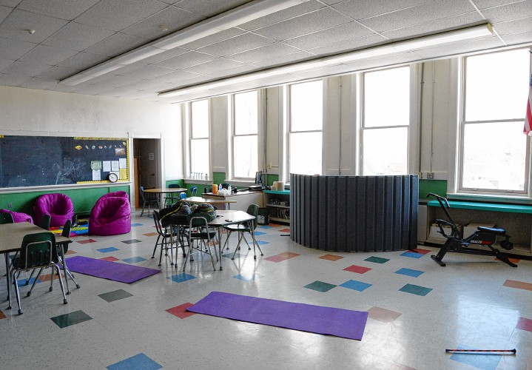
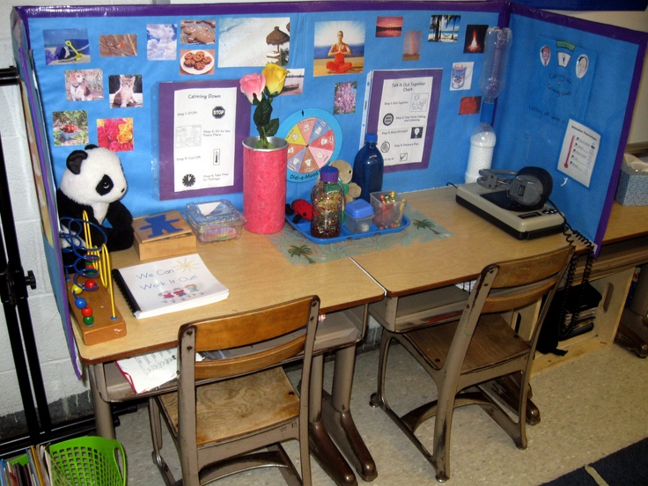

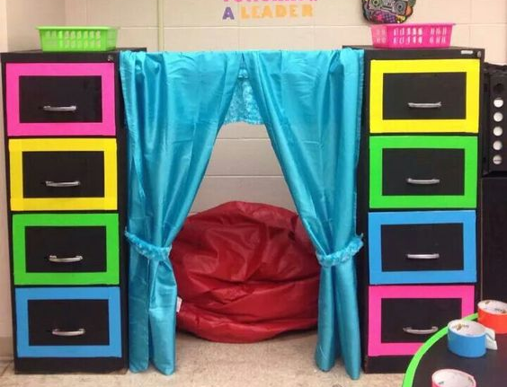
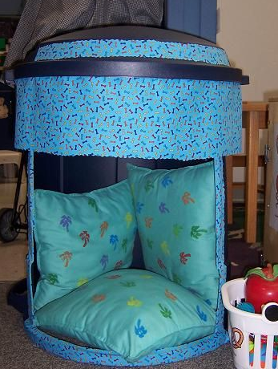
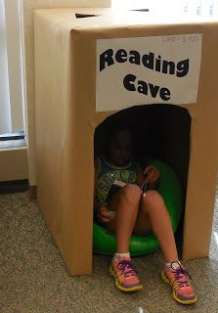
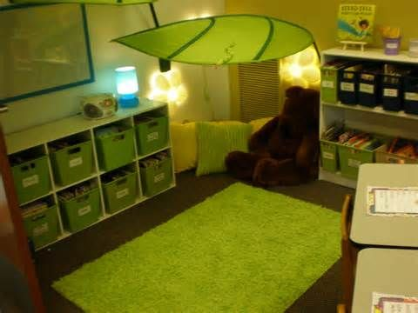
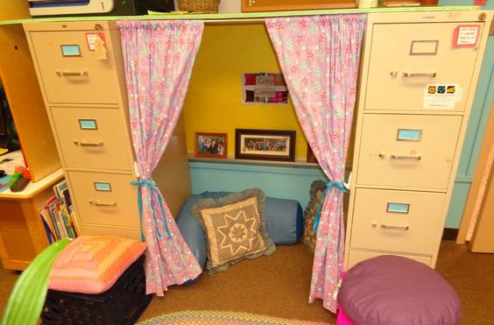
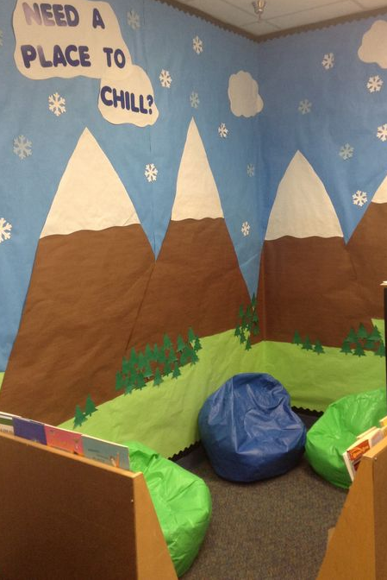
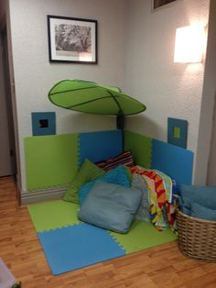

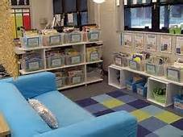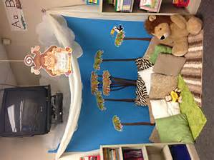
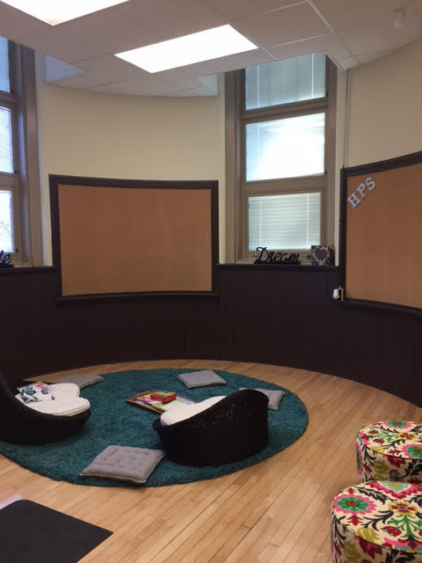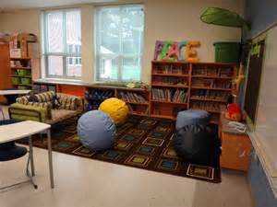

Resources:

Boston EdTalks video features teacher, Colleen Labbe, sharing trauma sensitive social emotional learning classroom strategies. She discusses the purpose and outcome of a comfort space.
https://traumasensitiveschools.org/
Direct link to video: https://www.youtube.com/watch?v=iV1-vnAvsAo
Video shows how high school students personally react to calming strategies and how it improves their lives.
http://www.calmclassroom.com/#video-1
This link is to a Go Fund Me page where a high school girl who is diagnosed with anxiety and on an IEP explains why she is raising money for her school to have a comfort space.
https://www.gofundme.com/22wkf6bn
This resource describes comfort room’s purposes and what they include.
http://www.omh.ny.gov/omhweb/resources/publications/comfort_room/
This page shows the different effects that colors can have.
http://www.colorpointinstitute.com/meaningofcolors.htm

